The Central Limit Theorem: Practice;
The Central Limit Theorem

Student Learning Outcomes:

- The student will explore the properties of data through the Central Limit Theorem.

Given:

Yoonie is a personnel manager in a large corporation. Each month she must review 16 of the employees. From past experience, she has found that the reviews take her approximately 4 hours each to do with a population standard deviation of 1.2 hours. Let X be the random variable representing the time it takes her to complete one review. Assume X is normally distributed. Let be the random variable representing the average time to complete the 16 reviews. Let ΣX be the total time it takes Yoonie to complete all of the month’s reviews.

Distribution

Complete the distributions.

1. X ∼ _________________________

2. ∼ _________________________

3. ΣX ∼ _________________________

Graphing Probability

For each problem below:

a. Sketch the graph. Label and scale the horizontal axis. Shade the region corresponding to the probability.

b. Find the probability.

1. Find the probability that one review will take Yoonie from 3.5 to 4.25 hours.
a. 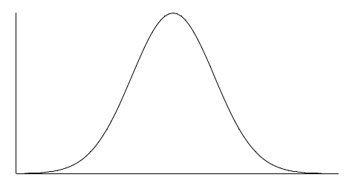
X
b. P( ________ < X < ________ ) = _______

2. Find the probability that the average of a month’s reviews will take Yoonie from 3.5 to 4.25 hrs.
a.
b. P( ) = _______

3. Find the 95th percentile for the average time to complete one month’s reviews.

a. b.

4. Find the probability that the sum of the month’s reviews takes Yoonie from 60 to 65 hours.

a.
ΣX
b. The Probability = _____________________

5. Find the 95th percentile for the sum of the month’s reviews.

a. b.
ΣX
b. The 95th Percentile = ____________________

Discussion Question

6. What causes the probabilities in (1) and (2) to differ?

